Data Mining Work Report
As in our plan, we have been focused on integrating the original one-minute data of building load as well as other building related characteristics like indoor environmental information (indoor temperature, relative humidity and CO2) from the database into daily data tables and apply numerical prediction and classification on those tables. During our practice, we tried different preprocessing methods including data cleaning, transformation, integration, reduction, normalization and discretization and various machine learning algorithms including Neural Networks, Relevance Vector Machine, k-NN, Rule Induction, Decision Tree and Random Forest and Support Vector Machine.

Data Description Methodology for Load Forecasting
This research is based on the data of building load and other related indoor environmental information of DHA Building at Albany. Each of the examples recorded from February 2012 represents the information of one minute. In addition to this data set, the weather information (temperature, humidity, wind speed, cloud cover, pressure, etc.) collected from August 2012 is also stored in an hourly-based data set.

A predictive model is built based on the historical daily building load consumption and weather data. Once the weather forecasting data becomes available, the load can be computed with the predictive model. The following diagram illustrates the model extraction and daily load estimation process.

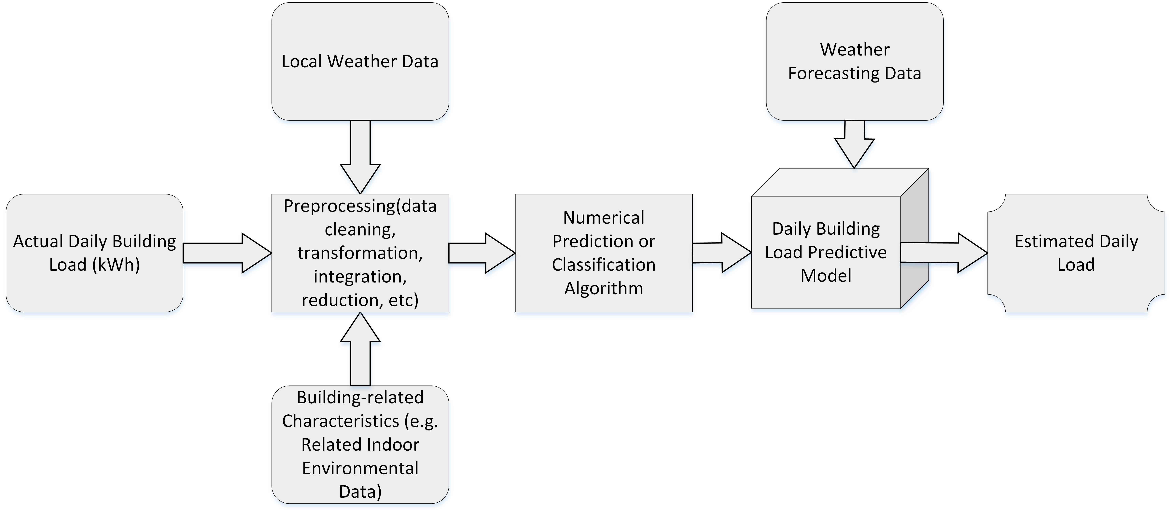

Approaches of Study

  - Data Cleaning
How to handle missing values is the main concern for data cleaning. Here a missing value is replaced with its previous or next available value (the one that is more close to the missing value is chosen). For example, the part of the table (left one of the following tables) containing missing values will be transformed to the right one:

6.839
0
0
0
6.618
6.667

6.839
6.839
6.839
6.618
6.618
6.667

  - Data Aggregation
For both the original one-minute data records of building load and related indoor environmental information and one-hour data records of Albany’s weather (the building is located at Albany), we need to aggregate all the ones within each day and hence obtain the daily data records for the later training and prediction or classification. Specifically, minutely load values within each day are summed while the average (*Avg), standard deviation (*Std), minimum value (*Min) and maximum value (*Max) of hourly temperature, humidity and wind speed values are respectively calculated.

  - Data Integration
In order to gain daily load forecasting models through training, the two daily data tables we gained from data aggregation (one is for building load and indoor environmental related information and the other one is for Albany’s weather) are combined into one table based on the same dates.

Additionally, some other calendar variables are attached as input features. As data present weekly cycles, the day of week were considered, that is, the type of day d is coded by taking values from 0 to 6 for Monday–Sunday, i.e. the day is weekend if the flag is 5 or 6, and sw = sin (2πd/7) and cw = cos(2πd/7) represent the day of week. On the other hand, the occupancy of the building is supposed to a have strong effect on the energy use, and whether the building is in session or not is important. Thus, weekends and holidays were identified and days were classified and the variable is_workday is encoded as -1 (weekday or workday) and 1 (weekend or holiday).

In regards to the daily load forecasting, the effect of the load of a few days ahead should be taken into account in consideration of the role of history in the dynamics. Thus, the load of one day ahead and two day ahead (oda_load and tda_load) are also used as the possible inputs for numerical prediction or classification.

  - Attribute Construction
The average of the minimum and maximum values of the daily temperature, humidity and wind speed (AvgMMTemp, AvgMMHumidity and AvgMMWindspeed) as well as the difference between the outdoor and indoor environmental parameters (TDif for temperature difference and HDif for humidity difference) are respectively calculated and added from the set of attributes to be investigated for the later mining process.

  - Data Reduction
Of all the potential input variables (or attributes) we have gained so far, some of them are indeed irrelevant to the mining task or redundant. Leaving out relevant attributes or keeping irrelevant attributes may be detrimental, causing confusion for the mining algorithm employed. This can result in discovered models of poor quality. In addition, the added volume of irrelevant or redundant attributes can slow down the mining process. Therefore, it is necessary to take dimensionality reduction in which irrelevant, weakly relevant, or redundant attributes or dimensions are detected and removed.

The following table can be obtained by calculating the correlation coefficient of each attribute and daily load along the whole sample daily dataset from 2/16/2012 through 12/15/2013. As shown, when the correlation threshold is set at 0.2, only five variables, namely HDif, oda_load, cw, sw

Attributes | Correlation Coefficient
TMax | 0.01
WAvg | 0.02
TStd | 0.03
TAvg | 0.04
WStd | 0.04
WMax | 0.04
AvgMMTemp | 0.04
HMin | 0.05
HMax | 0.05
HAvg | 0.06
TMin | 0.06
RH_IN | 0.11
Temp_IN | 0.11
WMin | 0.13
HStd | 0.14
CO2_IN | 0.18
tda_load | 0.18
TDif | 0.19
HDif | 0.24
cw | 0.40
oda_load | 0.44
sw | 0.68
is_workday | 0.81
Key: TMax = maximum temperature, TMin = minimum temperature, AvgMMTemp = average of maximum and minimum temperature, TAvg = temperature average, TStd = temperature standard deviation, WMax = maximum wind peed, WMin = minimum wind speed,WAvg = wind speed average, WStd = temperature standard deviation, HMax = maximum humidity, HMin = minimum humidity, HAvg = humidity average, HStd = humidity standard deviation, Temp_IN = indoor temperature, RH_IN = indoor relative humidity, CO2_IN = indoor CO2, oda_load = load of one days ahead, tda_load = load of two days ahead, TDif = difference between outdoor and indoor temperature, HDif = difference between outdoor and indoor humidity, cw = cos(day of week), sw = sin(day of week)

and is_workday, correlate to the output daily load. To be noticed, this results may not exactly reflect the influence of some variables on the daily load in some specific cases, i.e. various seasons and weather conditions etc. This will be given more discussion later.

As shown in the following table of correlation coefficients of each pair of attributes, TAvg, TMax, TMin and AvgMMTemp have a strong linear relationship. Therefore, no more than one of them should be considered as input attributes for training at the same time.

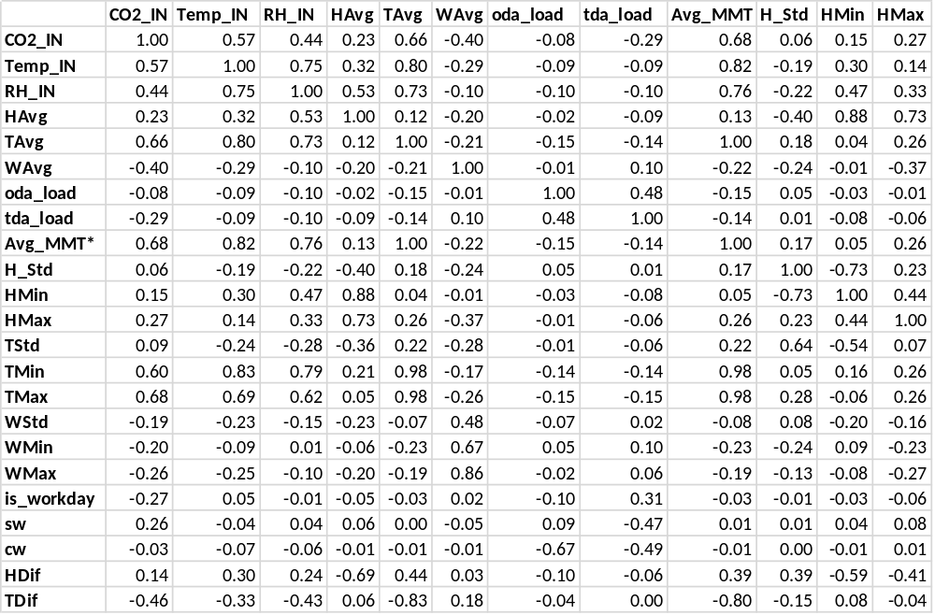

(Continuing Table)
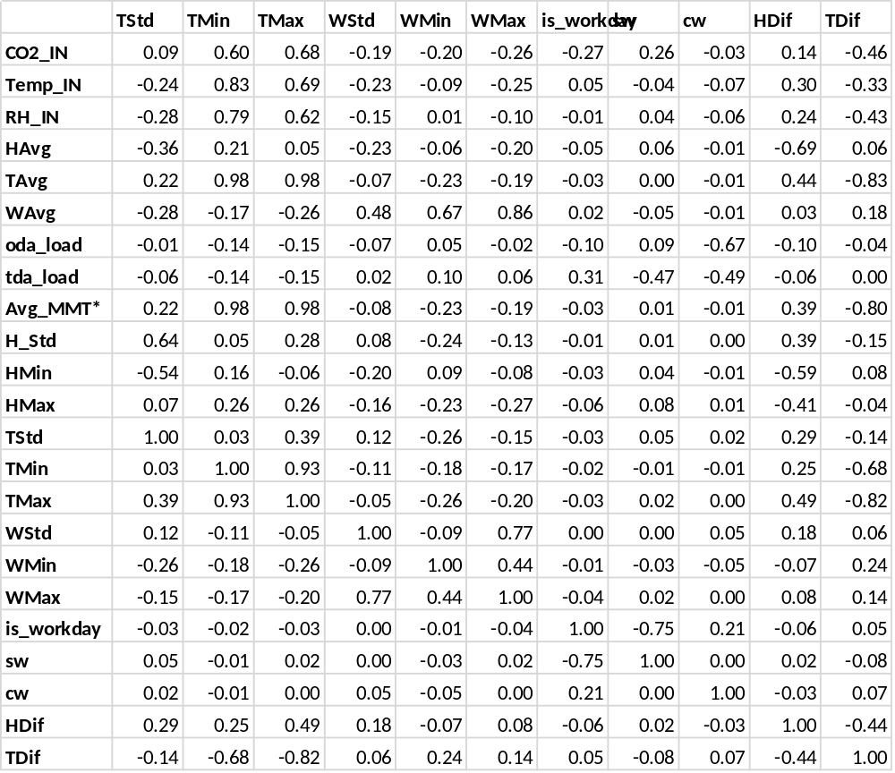
*Avg_MMT = AvgMMTemp

  - Data Normalization
In order to give all the attributes an equal weight, each of the attributes are scaled so as to fall within a small common range, such as -1 to 1, or 0 to 1. Normalization is particularly useful for machine learning algorithms involving neural networks or distance measurements such as nearest-neighbor regression or classification. Here z-score normalization is adopted.

  - Data Discretization by Binning
In order to use classification, it is required to transform numerical values of daily load into nominal values. Simply the range of numerical values can be partitioned into segments of equal size, and each segment represents a bin. Numerical values are assigned to the bin representing the segment covering the numerical value. Specifically, the min value (e.g. 10000 kWh) and max value (e.g. 90000 kWh) are given for defining the boundaries of the range. If there are any values that are less than the min value parameter, a separate range is created for them. Similarly if there are any values that are greater than the max value parameter, a separate range is created for them.

Results and Analysis
The results and comparison of numerical prediction (regression) and classification, which are respectively practiced for the daily building load forecasting, are presents here:

  - Numerical Prediction
The root-mean-square error (RMSE), mean-absolute error (MAE) and mean-absolute-percentage error (MAPE) are used as a performance measures in our model comparison. They are respectively defined as
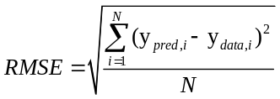
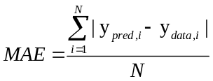
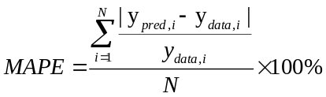
where y_{pred,i} is the predicted value of daily load, y_{data,i} is the correspondent actual value of daily load and N is the total number of examples for testing. So far neural networks (NN), relevance vector machine (RVM) and k-Nearest Neighbor (k-NN) have been investigated. By using each of them respectively, the numerical prediction results are shown as follows:

    - Neural Networks (NN)
When using NN as the kernel training algorithm, by testing it for daily load forecasting of 5 days ahead over the whole daily data table from necessary preprocessing approaches, we obtain the following results:

Performance of daily load forecasting based on NN with five input attributes: HDif, oda_load, cw, sw and is_workday
Training Window  Size  Performance | 30 | 40 | 50 | 60 | 70 | 80
RMSE | 18503.59+/- 5086.67 | 19381.10+/- 4924.35 | 18697.75+/- 5997.84 | 19456.14+/- 5748.37 | 19980.58+/- 6650.27 | 21520.09+/-6110.660
MAE | 15532.95+/- 4412.38 | 15946.59+/- 4282.17 | 15368.93+/- 5250.18 | 15752.73+/- 4975.59 | 16763.43+/- 6012.94 | 18526.01+/- 6452.90
MAPE | 55.02%+/- 35.58% | 58.11%+/- 37.93% | 54.19%+/- 39.44% | 62.06%+/- 38.64% | 61.00%+/- 37.36% | 68.16%+/- 32.11%

Performance of daily load forecasting based on NN with four input attributes: oda_load, cw, sw and is_workday
Training Window  Size  Performance | 40 | 50 | 60 | 70 | 80 | 90
RMSE | 9947.26 +/- 5778.77 | 9329.53 +/- 4462.48 | 9862.56 +/- 4454.46 | 8427.49 +/- 3852.99 | 8971.30 +/- 3753.43 | 10330.04 +/- 4650.60
MAE | 7912.83 +/- 4167.42 | 7549.72 +/- 3796.22 | 7957.79 +/- 3503.47 | 6780.76 +/- 3071.43 | 7313.77 +/- 2940.62 | 8335.29 +/- 3998.75
MAPE | 20.89% +/- 14.27% | 19.26% +/- 12.12% | 20.54% +/- 9.72% | 18.07% +/- 10.23% | 19.75% +/- 10.84% | 25.81% +/- 18.24%

It can be seen that it results in much higher prediction accuracy to only use oda_load, cw, sw and is_workday as input for model training. In this case, sliding training window size of approximate 70 is preferred.

    - Relevance Vector Machine (RVM)
When using RVM as the kernel training algorithm, by testing it for daily load forecasting of 5 days ahead over the whole daily data table from necessary preprocessing approaches, we can still observe that prediction results is of much higher quality without considering HDif as input. Specifically, the testing results is summarized as follows:

Performance of daily load forecasting based on RVM with four input attributes: oda_load, cw, sw and is_workday
Training Window  Size  Performance | 40 | 50 | 60 | 70 | 80
RMSE | 16411.47+/- 13002.05 | 17680.16+/- 14756.800 | 12979.85+/- 9760.90 | 12136.00+/- 10328.62 | 13759.37+/- 12633.89
MAE | 14441.76+/- 12410.93 | 15829.37+/- 14547.64 | 11414.84+/- 9237.05 | 10386.92+/- 9459.77 | 11975.91+/- 11567.95
MAPE | 37.33% +/- 25.07% | 37.12% +/- 24.31% | 29.05% +/- 19.16% | 29.24% +/- 21.60% | 33.37% +/- 24.59%

Obviously, when the sliding training window size is taken around 60-70, we will get the highest accuracy for the daily load prediction of 5 days ahead.

    - k-Nearest Neighbor (k-NN)
The k-NN algorithm is based on learning by analogy, that is, by comparing a given test example with training examples that are similar to it. Although the best value of k (usually a small positive integer) is not sure, we can temporarily set k=5 here to obtain the results (more discussion on it will be given later) which is displayed as follows:

Performance of daily load forecasting based on k-NN with four input attributes: oda_load, cw, sw and is_workday
Training Window  Size  Performance | 40 | 50 | 60 | 70 | 80 | 90
RMSE | 7832.49+/- 3063.32 | 7607.05+/- 3010.18 | 7524.10+/- 2927.78 | 7220.76+/- 2902.17 | 6868.55+/- 3400.37 | 9217.54+/- 2937.59
MAE | 6153.79+/- 2419.81 | 5989.27+/- 2392.53 | 5796.98+/- 2251.84 | 5566.53+/- 2050.77 | 5544.82+/- 2646.18 | 7359.78+/- 2315.48
MAPE | 18.63% +/- 9.82% | 17.16% +/- 8.84% | 14.25% +/- 5.33% | 15.18% +/- 7.05% | 13.60% +/- 6.45% | 17.72% +/- 5.21%

It is clear that we are supposed to get the highest accuracy for the daily load prediction of 5 days ahead when using the sliding training window of length of 60-80.

Comparing the the results of 3.1.1 – 3.1.3 shows that k-NN is the best of the NN, RVM and k-NN in terms of load prediction accuracy.

    - The Effect of changing k for k-NN
For k-NN, the positive integer k means the k "nearest neighbors" (training examples) of the unknown example. Specifically, when given an unknown example, the k-NN algorithm searches the pattern space for the k training examples that are closest to the unknown example, and assign their average as the label value for that example. Here the effect of different k’s value on forecasting performance is studied.

Performance of daily load forecasting based on k-NN with four input attributes: oda_load, cw, sw and is_workday
k  Performance | 3 | 4 | 5 | 6 | 7
RMSE | 9040.516 +/- 5627.341 | 8729.143 +/- 5495.810 | 8651.454 +/- 5592.943 | 8640.283 +/- 5648.474 | 8655.236 +/- 5537.183
MAE | 7230.561 +/- 4435.467 | 6963.668 +/- 4279.360 | 6855.740 +/- 4287.638 | 6878.142 +/- 4321.555 | 6937.188 +/- 4300.881
MAPE | 18.49% +/- 16.38% | 17.82% +/- 15.72% | 17.55% +/- 15.49% | 17.80% +/- 15.70% | 18.17% +/- 16.41%

It can be seen that when k’s value is around 4-6, the prediction accuracy is a little higher. Since k is provided with an odd integer value in most cases, it is reasonable to set k=5 as we did in 3.1.3. In this case, the testing results of daily building load forecasting can be shown as following figure:

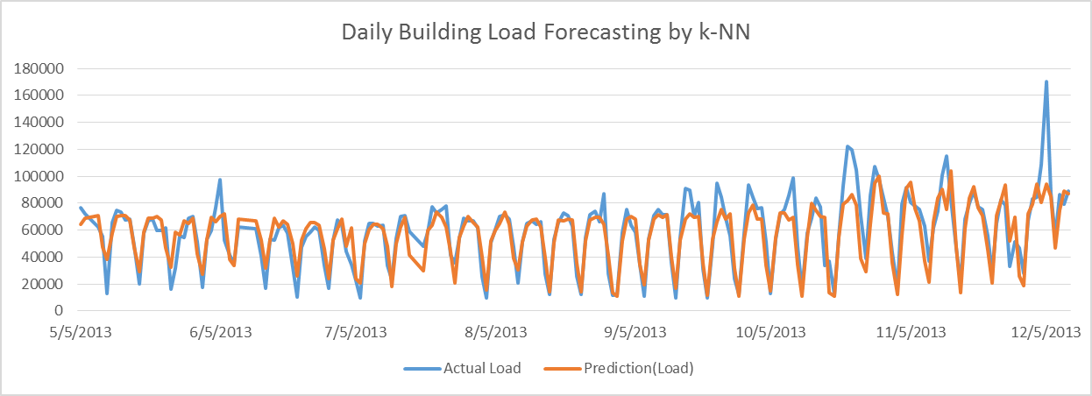

  - Classification
The classification accuracy are used as a performance measures in our model comparison. So far several classification algorithm have been investigated in RapidMiner, and k-NN, Rule Induction, Decision Tree and Random Forest proved to be of better performance than others. For each of them, the classification accuracy are shown as follows:

Classification accuracy of daily load classification based on k-NN, Rule Induction, Decision Tree, Random Forest and Support Vector Machine (SVM) with four input attributes: oda_load, cw, sw and is_workday
Load Binning  Size  Performance | 5 | 7 | 9
k-NN (k=5) | 61.96% | 45.93% | 39.87%
Rule Induction | 57.03% | 42.90% | 35.08%
Decision Tree | 59.05% | 43.41% | 39.18%
Random Forest | 59.12% | 44.42% | 37.48%
SVM | 59.64% | 45.70% | 39.58%

Obviously, the performance of classification become worse when the number of classes increases. The following example (by using SVM) shows how the classification works for daily load predication of five day ahead

